|  |
| --- |
| BLUEsat UNSW Student Satellite Project  Document BLUE.2011.3.0 |
| Battery Charge Regulator |
| Progress Report Aug 2012 |
| **Authors and Contributors:**  Thomas Fisk Mitch Wenke  **Date:** |
| August 11, 2012 |

# Introduction

The BLUEsat Battery Charge Regulator (BCR) is a key component of the satellite bus that has been designed from scratch by our Power Team. It features six redundant battery chargers which allow independent peak power point tracking for the satellite’s six solar panels.

We have proven our design and are currently on our 2nd PCB revision of the complete subsystem prototype. Current efforts are focused on finalising software for the independent BCR microcontroller.

# Table of Contents

1 Introduction 1

2 Table of Contents 1

3 Requirements 2

4 Summary of Design 3

5 Current Progress 3

6 Future Work 4

# Specifications

The purpose of the Battery Charge Regulator (BCR) subsystem is to efficiently draw power from the solar array to power the load and charge the batteries. The BCR subsystem

## Power requirements of BLUEsat mission

The BLUEsat balloon launch mission is expected to last several days. In Alice Springs around March 2013, the day/night cycle will be approximately 12 hours of daylight and night-time[1]. Average power consumption could be up to 11.6 W (**see power budget document**) assuming the transmitter radios are permanently switched on at full power (this is an unlikely scenario, so the actual average power requirements will be much less.

## Maximum Power Point Tracking

In order to draw power from Because of the IV characteristic of photovoltaic cells, illustrated in Figure 3.1.1.

Maximum Power Point Tracking (MPPT) is required in order to efficiently draw power from the solar array.

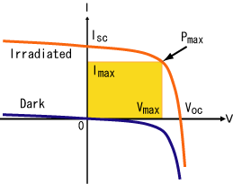

Figure 3.1.1 – IV characteristic of solar cells[2]

# Summary of Design

## System design

The system design of the battery charge regulator subsystem is illustrated in Figure 4.1.1. A more detailed overview of the system can be found in the schematic (**see POWR0008**). The design uses up to 6 SEPIC switch mode regulators, one for each solar panel.

The core of the BCR subsystem is an Atmel ATXMEGA64A3 microcontroller, which will be from here referred to as the BCR Controller. This is completely independent from the Critical Systems Computer (CSC). The ADC on the BCR controller is used to measure panel voltages and currents and control the Maximum Power Point Tracking (MPPT), as well as to measure battery voltage, battery current and load current.

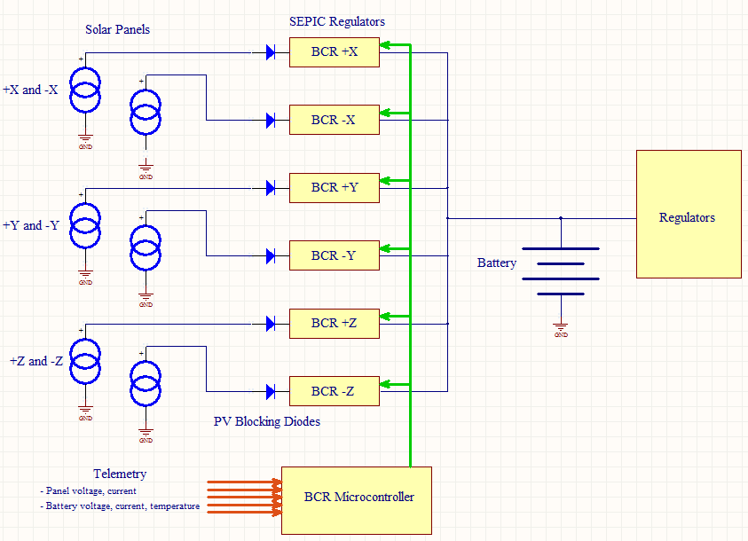

Figure 4.1.1 – BCR system design

## Circuit Design

The SEPIC regulators used are based on the Linear Technologies LT1513-2 IC (**see LT1513-2 datasheet, POWR0001 for schematic**). The SEPIC topology and LT1513-2 IC were chosen for the following reasons:

* SEPIC topology allows input voltage above and below the battery voltage.
* LT1513-2 can operate in constant current mode with a voltage adjustable current limit. This is required for charging NiMH batteries and for Maximum Power Point Tracking (MPPT).
* The SEPIC topology is commonly used in other Cubesat and Microsatellite power systems, such as those developed by Clyde Space[3].

## Battery Charging

BLUEsat uses 14 Nickel Metal Hydride (NiMH) cells arranged in series to power satellite during night-time and to provide a reservoir for when power is needed exceeding the power generated by the solar array (e.g. when transmitting).

NiMH batteries are typically charged in constant current mode. The NiMH cells on BLUEsat are charged by whatever current generated by the SEPIC regulators is not used immediately by the rest of the satellite. Because of this, the current entering the battery is not constant.

NiMH cells have a particular behaviour that when the cell reaches full charge, more of the charging energy is converted into heat. To detect when the batteries are full and prevent overcharging, ΔT charge termination is required. This is typically done by using a temperature sensor thermally coupled to the batteries. When the temperature exceeds an absolute temperature cut-off, charging is disabled until the temperature cools to a certain value. Charge termination has yet to be implemented into the design, however will likely use an existing temperature sensor implemented as part of the Telemetry subsystem.

## Maximum Power Point Tracking

Photovoltaic Maximum power point tracking is implemented using a Perturb and Observe algorithm, described in Figure 4.4.2. The maximum power point is perturbed by perturbing the constant current limit control voltage of the SEPIC regulator. A digital to analogue converter (DAC) is used to set the constant current limit control voltage for each SEPIC regulator. The on-board 16 channel ADC of the BCR controller (ATXMEGA64A3) is used to measure the voltage and current supplied by each solar panel.

Control of maximum charge current provided by the SEPIC regulators is used for the implementation of the Maximum Power Point Tracker. Tracking is performed separately for each solar panel, of which has its own SEPIC regulator.

Yes

No

Yes

No

Begin

Increase panel current

Is Power greater than last measured power?

Measure panel power (V*I) using ADC

Decrease panel current

Is Power greater than last measured power?

Measure panel power (V*I) using ADC

Figure 4.4.2 – Perturb and Observe algorithm flowchart

# Current Progress

The first prototype was completed in late 2011, shown in Figure 5.1. This prototype underwent extensive testing, and performed for the most part as designed. A few issues, particularly with stability and voltage ripple were discovered.

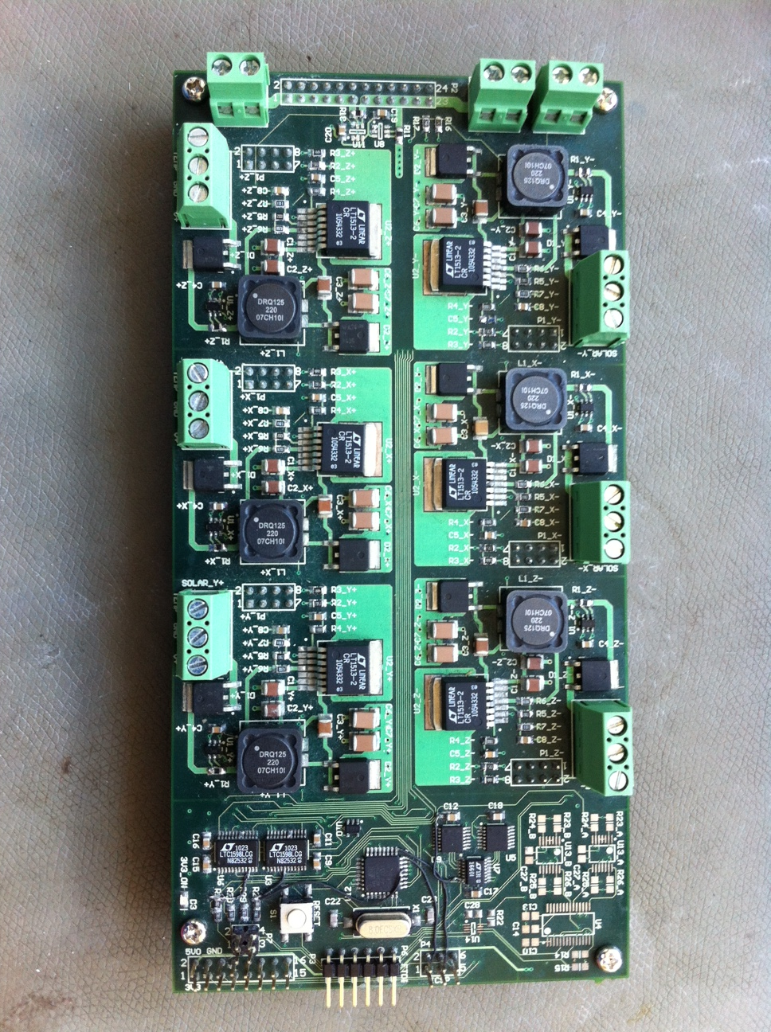

Figure 5.1 – First prototype of BCR subsystem

A second prototype was designed in early 2012, improving on the previous revision. The main differences are:

* Changes to SEPIC regulator circuitry to improve stability of power supply
* Change from ATMEGA328P microcontroller to ATXMEGA64A3 microcontroller for BCR control. Uses internal ADC on microcontroller instead of external ADC.
* Synchronises the switching frequencies of parallel regulators to reduce noise.
* Corrected design errors.
* More compact layout that will fit on the final Tray 2 PCB.

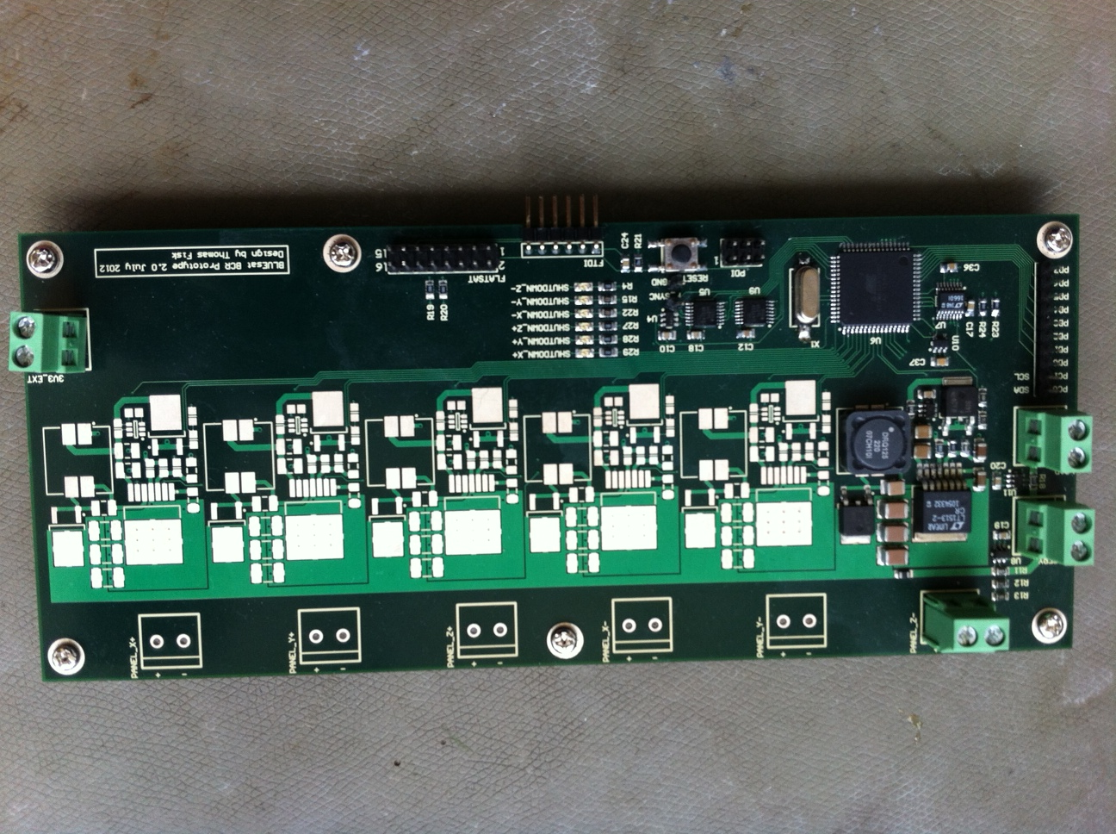

Figure 5.2 – Second prototype of BCR subsystem prototype

# Future Work

Currently, efforts are focused towards finalising software for the BCR controller. Future efforts will be devoted to further hardware testing, particularly the Maximum Power Point Tracking (MPPT) functionality.

Once the design has been further proofed it can be integrated into the Tray 2 PCB.

1. Source: www.timeanddate.com/worldclock/astronomy.html?n=929&month=3&year=2012&obj=sun&afl=-11&day=1
2. Source: Wikipedia
3. See http://www.clyde-space.com/documents/2471